**LAB Logbook**

**Lab 1**

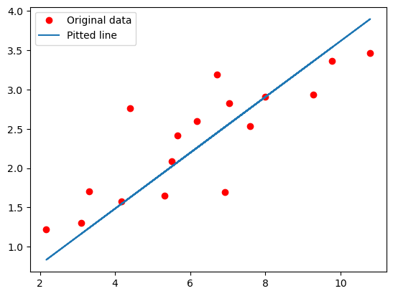

**Lab 2**

0.93

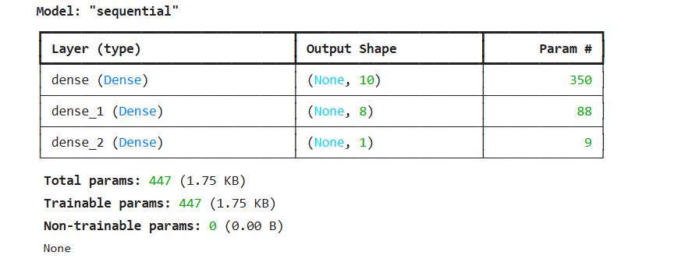

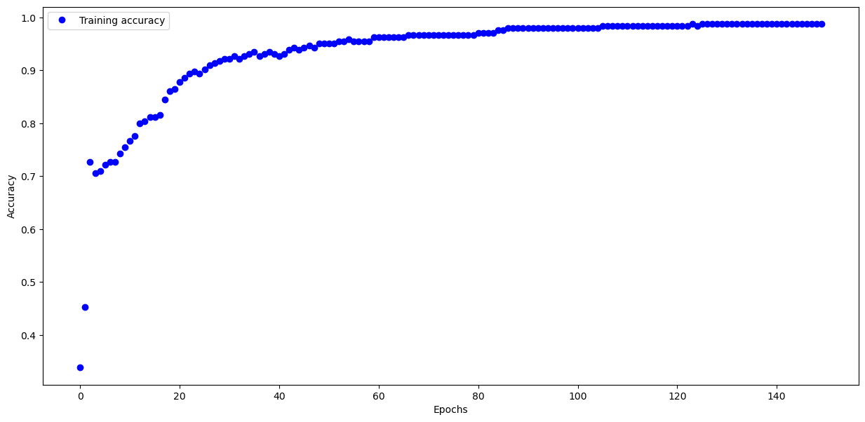

**Lab 3**

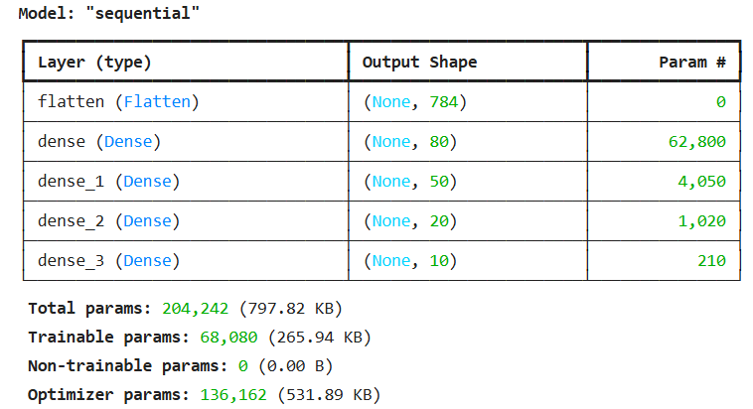

**Test accuracy: 0.8870999813079834**

**Lab 4**

**Lab 5**

**Lab 6**

**Lab 7**

**Lab 8**

**Lab 9**

**Lab 10**

**Lab 11**

**Lab 12**